**Báo cáo OOP Lab 2**

**Họ và tên:** Lê Nguyên Khải

**MSSV:** 20225727

**Class Diagram:**

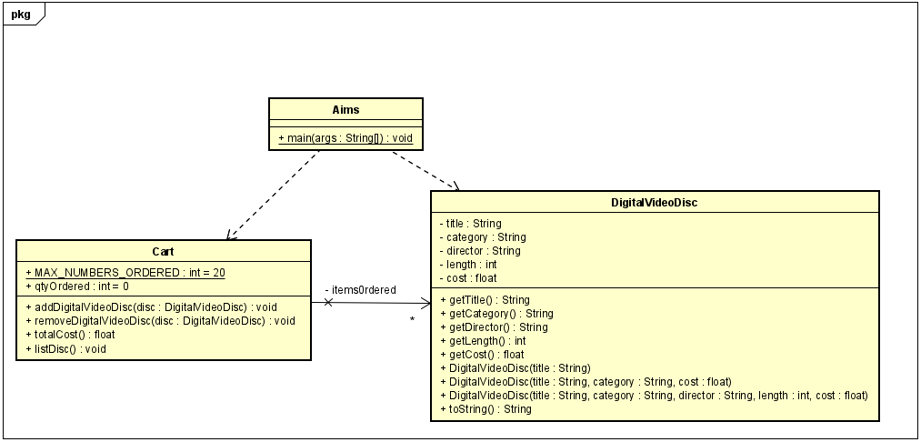

**UseCase Diagram:**

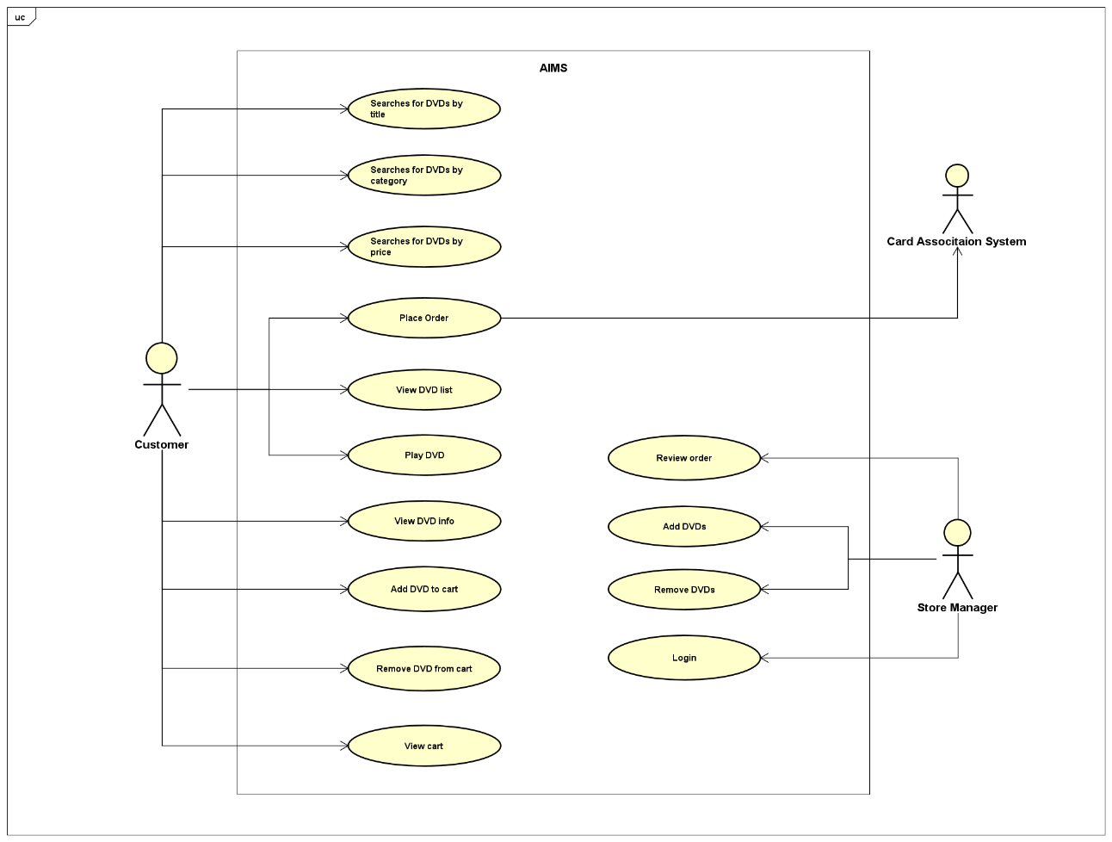

**Reading Assignment:**

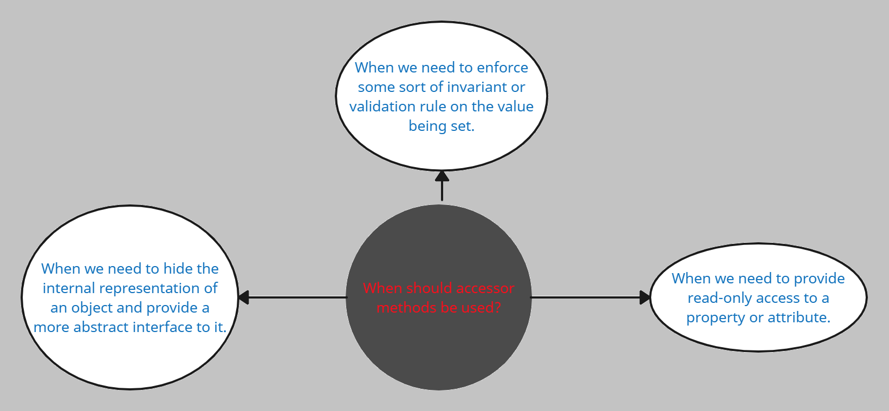

**Code:**

* **DigitalVideoDisc class:**

**public** **class** DigitalVideoDisc {

**private** String title;

**private** String category;

**private** String director;

**private** **int** length;

**private** **float** cost;

**public** DigitalVideoDisc(String title) {

**super**();

**this**.title = title;

}

**public** DigitalVideoDisc(String title, String category, **float** cost) {

**super**();

**this**.title = title;

**this**.category = category;

**this**.cost = cost;

}

**public** DigitalVideoDisc(String title, String category, String director, **float** cost) {

**super**();

**this**.title = title;

**this**.category = category;

**this**.director = director;

**this**.cost = cost;

}

**public** DigitalVideoDisc(String title, String category, String director, **int** length, **float** cost) {

**super**();

**this**.title = title;

**this**.category = category;

**this**.director = director;

**this**.length = length;

**this**.cost = cost;

}

**public** String getTitle() {

**return** title;

}

**public** **void** setTitle(String title) {

**this**.title = title;

}

**public** String getcategory() {

**return** category;

}

**public** **void** setcategory(String category) {

**this**.category = category;

}

**public** String getDirector() {

**return** director;

}

**public** **void** setDirector(String director) {

**this**.director = director;

}

**public** **int** getLength() {

**return** length;

}

**public** **void** setLength(**int** length) {

**this**.length = length;

}

**public** **float** getCost() {

**return** cost;

}

**public** **void** setCost(**float** cost) {

**this**.cost = cost;

}

// @override

**public** String toString(){

**return** String.format("Title: %s, category: %s, director: %s, length: %d, cost: %.2f.",

**this**.title, **this**.category, **this**.director, **this**.length, **this**.cost);

}

}

* **Cart class:**

**public** **class** Cart {

**public** **static** **final** **int** ***MAX_NUMBERS_ORDERED*** = 20;

**private** DigitalVideoDisc items0rdered[] = **new** DigitalVideoDisc[***MAX_NUMBERS_ORDERED***];

**private** **int** qtyOrdered = 0;

**public** **void** addDigitalVideoDisc(DigitalVideoDisc disc) {

**if** (qtyOrdered < 20) {

items0rdered[qtyOrdered] = disc;

qtyOrdered += 1;

System.***out***.println("This disc has been added!");

} **else** {

System.***out***.println("This cart is almost full!");

}

}

**public** **void** removeDigitalVideoDisc(DigitalVideoDisc disc) {

**boolean** found = **false**;

**for** (**int** i = 0; i < qtyOrdered; i++) {

**if** (items0rdered[i] != **null** && items0rdered[i].equals(disc)) {

found = **true**;

**for** (**int** j = i; j < qtyOrdered - 1; j++) {

items0rdered[j] = items0rdered[j + 1];

}

items0rdered[qtyOrdered - 1] = **null**;

qtyOrdered -= 1;

System.***out***.println("This disc has been removed!");

**break**;

}

}

**if** (!found) {

System.***out***.println("This disc hasn't ever existed in this cart!");

}

}

**public** **void** listDisc() {

**for** (**int** i = 0; i < qtyOrdered; i++) {

System.***out***.println(items0rdered[i].toString());

}

}

**public** **float** totalCost() {

**float** total = 0;

**for** (**int** i = 0; i < qtyOrdered; i++) {

total += items0rdered[i].getCost();

}

**return** total;

}

}

* **Aims class:**

**public** **class** Aims {

**public** **static** **void** main(String[] args) {

Cart an0rder = **new** Cart();

DigitalVideoDisc dvd1 = **new** DigitalVideoDisc(

"The Lion King",

"Animation",

"Roger Allers",

87,

19.95f

);

an0rder.addDigitalVideoDisc(dvd1);

DigitalVideoDisc dvd2 = **new** DigitalVideoDisc(

"Star Wars",

"Science Fiction",

"George Lucas",

87,

24.95f

);

an0rder.addDigitalVideoDisc(dvd2);

DigitalVideoDisc dvd3 = **new** DigitalVideoDisc(

"Aladin",

"Animation",

18.99f

);

an0rder.addDigitalVideoDisc(dvd3);

an0rder.listDisc();

System.***out***.println("Total Cost is: ");

System.***out***.println(an0rder.totalCost());

DigitalVideoDisc dvd4 = **new** DigitalVideoDisc(

"Aladin Part2",

"Animation",

20.99f

);

an0rder.removeDigitalVideoDisc(dvd4);

an0rder.removeDigitalVideoDisc(dvd3);

an0rder.listDisc();

System.***out***.println("Total Cost is: ");

System.***out***.println(an0rder.totalCost());

}

}

**Kết quả:**

